Name: ______________________________________________

Directions: After reading, write an appropriate response for each space.

Name of story (use capitals and quotation marks): _________________________________________________________________________

Question: _____________________________________________________________________
______________________________________________________________________________
______________________________________________________________________________

Comment: _____________________________________________________________________
______________________________________________________________________________
______________________________________________________________________________
______________________________________________________________________________
______________________________________________________________________________
______________________________________________________________________________
______________________________________________________________________________

Quotation (include quotation marks and page number/s): ___________________________________________
______________________________________________________________________________
______________________________________________________________________________
______________________________________________________________________________
______________________________________________________________________________
_____________________________________________________________________________
______________________________________________________________________________

Connection: ___________________________________________________________________
______________________________________________________________________________
______________________________________________________________________________
______________________________________________________________________________
______________________________________________________________________________
______________________________________________________________________________
______________________________________________________________________________
Sci Fi category: _________________________________________________
Sci Fi motif/subjects (book refers to them as “themes”): ____________________________________
Name of story (use capitals and quotation marks): _________________________________________________________________________

Question: _____________________________________________________________________
______________________________________________________________________________
______________________________________________________________________________

Comment: _____________________________________________________________________
______________________________________________________________________________
______________________________________________________________________________
______________________________________________________________________________
______________________________________________________________________________
______________________________________________________________________________
______________________________________________________________________________

Quotation (include quotation marks and page number/s): ___________________________________________
______________________________________________________________________________
______________________________________________________________________________
______________________________________________________________________________
______________________________________________________________________________
_____________________________________________________________________________
______________________________________________________________________________

Connection: ___________________________________________________________________
______________________________________________________________________________
______________________________________________________________________________
______________________________________________________________________________
______________________________________________________________________________
______________________________________________________________________________
______________________________________________________________________________

Sci Fi category: _________________________________________________

Sci Fi motif/subjects (book refers to them as “themes”): ____________________________________
Name of story (use capitals and quotation marks): _________________________________________________________________________

Question: _____________________________________________________________________
______________________________________________________________________________
______________________________________________________________________________

Comment: _____________________________________________________________________
______________________________________________________________________________
______________________________________________________________________________
______________________________________________________________________________
______________________________________________________________________________
______________________________________________________________________________
______________________________________________________________________________

Quotation (include quotation marks and page number/s): ___________________________________________
______________________________________________________________________________
______________________________________________________________________________
______________________________________________________________________________
______________________________________________________________________________
_____________________________________________________________________________
______________________________________________________________________________

Connection: ___________________________________________________________________
______________________________________________________________________________
______________________________________________________________________________
______________________________________________________________________________
______________________________________________________________________________
______________________________________________________________________________
______________________________________________________________________________
Sci Fi category: _________________________________________________
Sci Fi motif/subjects (book refers to them as “themes”): ____________________________________

Name of story (use capitals and quotation marks): _________________________________________________________________________

Question: _____________________________________________________________________
______________________________________________________________________________
______________________________________________________________________________

Comment: _____________________________________________________________________
______________________________________________________________________________
______________________________________________________________________________
______________________________________________________________________________
______________________________________________________________________________
______________________________________________________________________________
______________________________________________________________________________

Quotation (include quotation marks and page number/s): ___________________________________________
______________________________________________________________________________
______________________________________________________________________________
______________________________________________________________________________
______________________________________________________________________________
_____________________________________________________________________________
______________________________________________________________________________

Connection: ___________________________________________________________________
______________________________________________________________________________
______________________________________________________________________________
______________________________________________________________________________
______________________________________________________________________________
______________________________________________________________________________
______________________________________________________________________________

Sci Fi category: _________________________________________________

Sci Fi motif/subjects (book refers to them as “themes”): ____________________________________

Name of story (use capitals and quotation marks): _________________________________________________________________________

Question: _____________________________________________________________________
______________________________________________________________________________
______________________________________________________________________________

Comment: _____________________________________________________________________
______________________________________________________________________________
______________________________________________________________________________
______________________________________________________________________________
______________________________________________________________________________
______________________________________________________________________________
______________________________________________________________________________

Quotation (include quotation marks and page number/s): ___________________________________________
______________________________________________________________________________
______________________________________________________________________________
______________________________________________________________________________
______________________________________________________________________________
_____________________________________________________________________________
______________________________________________________________________________

Connection: ___________________________________________________________________
______________________________________________________________________________
______________________________________________________________________________
______________________________________________________________________________
______________________________________________________________________________
______________________________________________________________________________
______________________________________________________________________________
Sci Fi category: _________________________________________________
Sci Fi motif/subjects (book refers to them as “themes”): ____________________________________

Name of story (use capitals and quotation marks): _________________________________________________________________________

Question: _____________________________________________________________________
______________________________________________________________________________
______________________________________________________________________________

Comment: _____________________________________________________________________
______________________________________________________________________________
______________________________________________________________________________
______________________________________________________________________________
______________________________________________________________________________
______________________________________________________________________________
______________________________________________________________________________

Quotation (include quotation marks and page number/s): ___________________________________________
______________________________________________________________________________
______________________________________________________________________________
______________________________________________________________________________
______________________________________________________________________________
_____________________________________________________________________________
______________________________________________________________________________

Connection: ___________________________________________________________________
______________________________________________________________________________
______________________________________________________________________________
______________________________________________________________________________
______________________________________________________________________________
______________________________________________________________________________
______________________________________________________________________________

Sci Fi category: _________________________________________________

Sci Fi motif/subjects (book refers to them as “themes”): ____________________________________

Name of story (use capitals and quotation marks): _________________________________________________________________________

Question: _____________________________________________________________________
______________________________________________________________________________
______________________________________________________________________________

Comment: _____________________________________________________________________
______________________________________________________________________________
______________________________________________________________________________
______________________________________________________________________________
______________________________________________________________________________
______________________________________________________________________________
______________________________________________________________________________

Quotation (include quotation marks and page number/s): ___________________________________________
______________________________________________________________________________
______________________________________________________________________________
______________________________________________________________________________
______________________________________________________________________________
_____________________________________________________________________________
______________________________________________________________________________

Connection: ___________________________________________________________________
______________________________________________________________________________
______________________________________________________________________________
______________________________________________________________________________
______________________________________________________________________________
______________________________________________________________________________
______________________________________________________________________________
Sci Fi category: _________________________________________________
Sci Fi motif/subjects (book refers to them as “themes”): ____________________________________

Name of story (use capitals and quotation marks): _________________________________________________________________________

Question: _____________________________________________________________________
______________________________________________________________________________
______________________________________________________________________________

Comment: _____________________________________________________________________
______________________________________________________________________________
______________________________________________________________________________
______________________________________________________________________________
______________________________________________________________________________
______________________________________________________________________________
______________________________________________________________________________

Quotation (include quotation marks and page number/s): ___________________________________________
______________________________________________________________________________
______________________________________________________________________________
______________________________________________________________________________
______________________________________________________________________________
_____________________________________________________________________________
______________________________________________________________________________

Connection: ___________________________________________________________________
______________________________________________________________________________
______________________________________________________________________________
______________________________________________________________________________
______________________________________________________________________________
______________________________________________________________________________
______________________________________________________________________________

Sci Fi category: _________________________________________________

Sci Fi motif/subjects (book refers to them as “themes”): ____________________________________

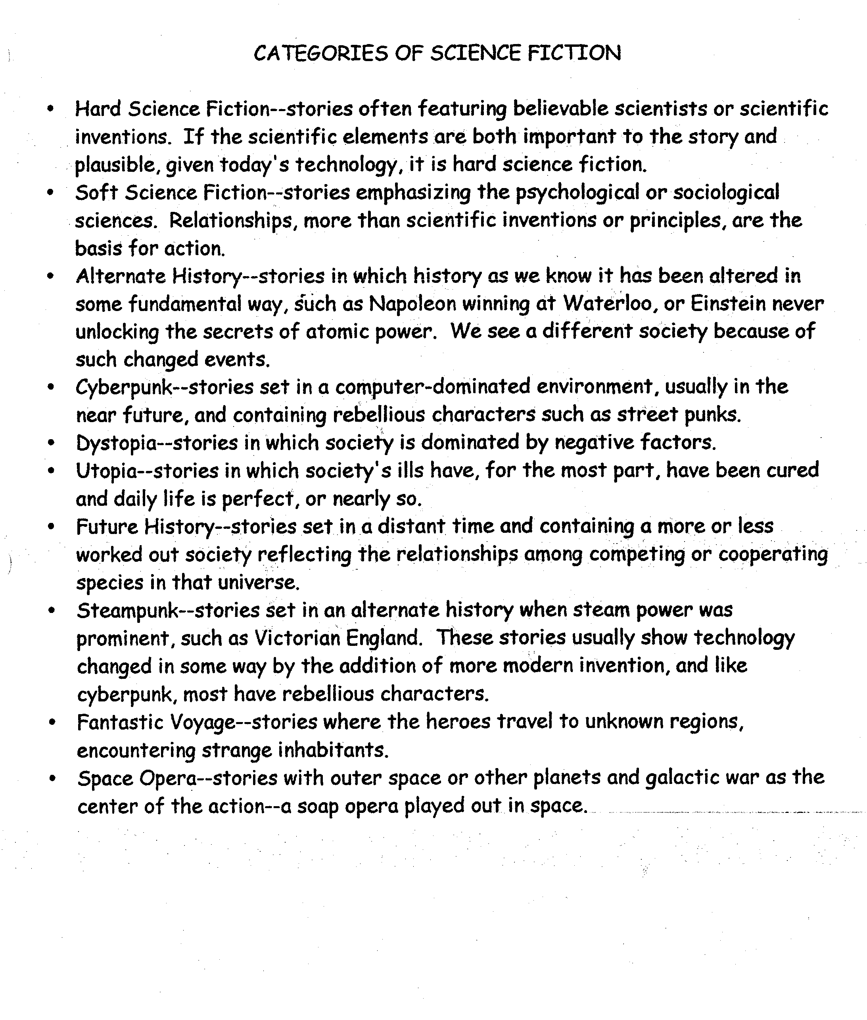

Please refer to these as “subjects,”
“topics” or “motifs,” common to Science Fiction stories: they are not fully-formed themes, even though they are labeled as such below.
